Manual and sketch of Imaging

- screwing**
  - Use screws to nail the log to the bottom laminate, with one end of the log in focus with the frame centre line to prevent errors caused by warping of the timber
**If the timber is sufficiently flat
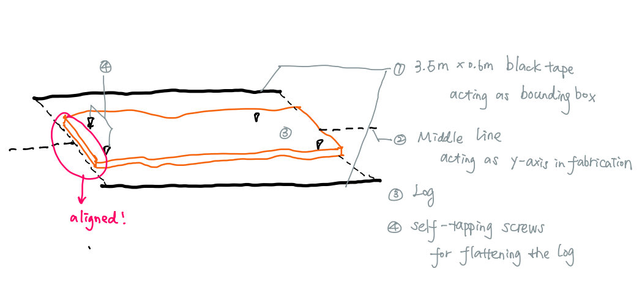

- labeling
  - middle point of the boundary box painted on the both ends of the log
  - the bottom of the bounding box as axis X →| direction
  - number 01,02…
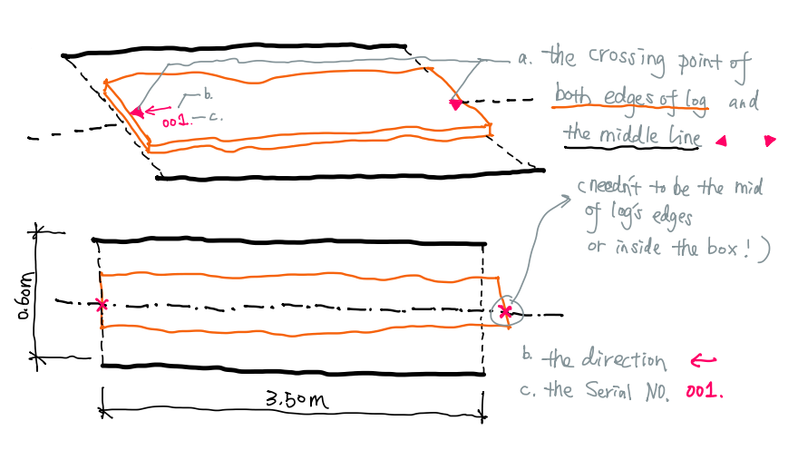

- photo
  - align the middle point and middle line of the boundary box with the camera’s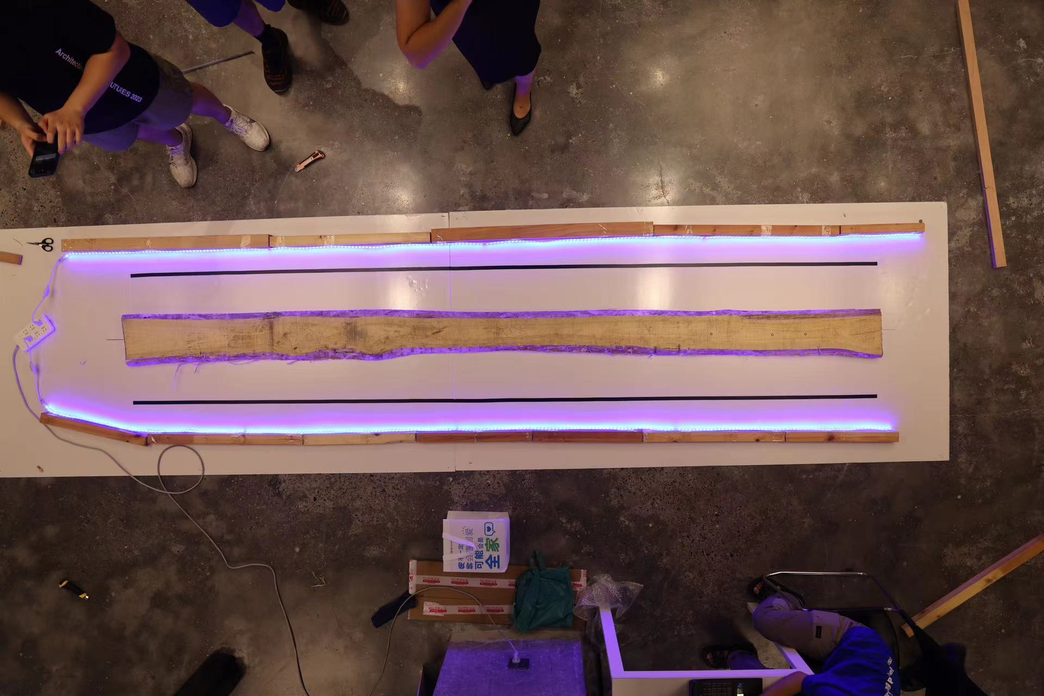

- imaging
  - Elimination of distortions
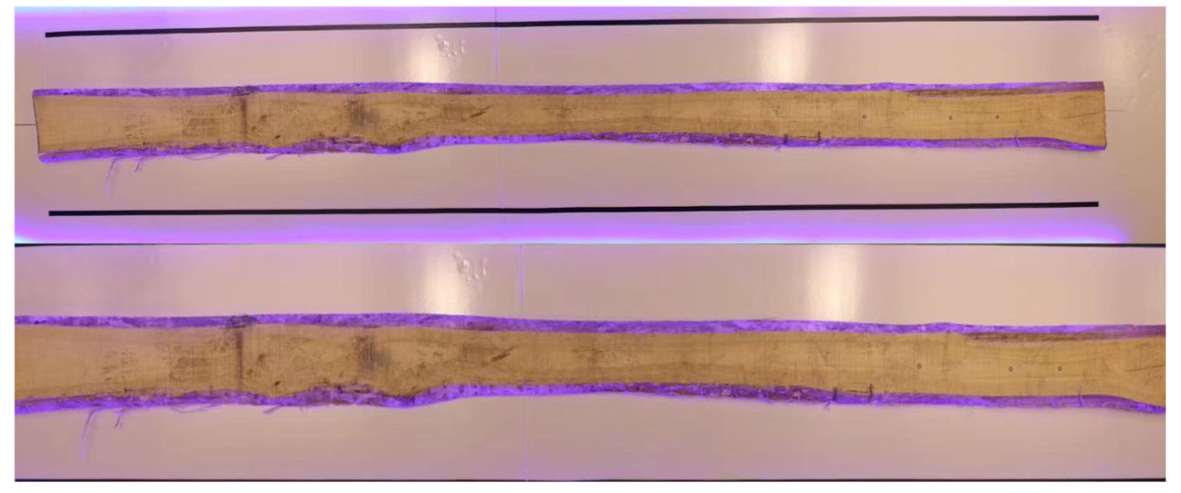
  - segmentation(with RGB)
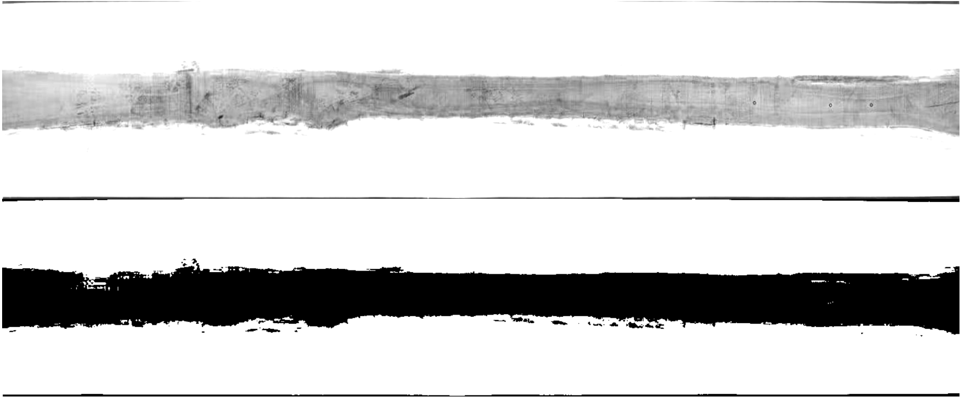
  - masking
  - denoising

  - apply a boundary box and middle line (.dxf)
output:
A mask (.png) for Algo group to calculate the area

A boundary box and middle line (.dxf) for DXF group to locate the Origin Point and X axis

- imag → DXF

- DXF → ALGO

- ALGO → DXF

- DXF → Fabrication

- cut the ends

